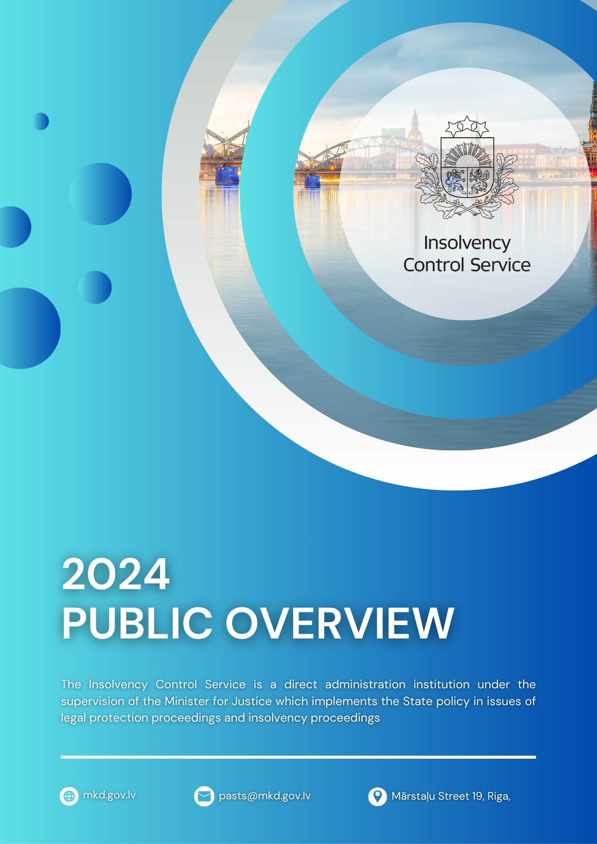

TABLE OF CONTENTS
1. BASIC INFORMATION 5
2. FINANCIAL RESOURCES OF THE INSOLVENCY CONTROL SERVICE AND PERFORMANCE 6
2.1. Official activities of the administrator 7
2.2. Supervision of administrators and LPP supervisory persons 8
2.2.1. Supervision under the Insolvency Law 8
2.2.1.1. Planned (risk-based) inspections 9
2.2.1.2. Complaint review 10
2.2.1.3. Supervision under the Prevention Law and Sanction Law 11
2.3. Administrative offence case review 12
2.4. Examination of employee claims and payment of amounts allocated to cover employee claims 13
2.5. Examination of deposit applications and payment of deposits 16
2.6. Administrating the costs of insolvency proceedings 17
2.7. Electronic Insolvency Accounting System development and user support 17
2.8. Services provided by the Insolvency Control Service, improvements in ensuring the availability and quality of services 18
3. STAFF OF THE INSOLVENCY CONTROL SERVICE 19
4. COMMUNICATION WITH THE PUBLIC 20
4.1. Communication channels, number of users and profile 20
4.2. Public information and education measures 21
4.3. Informative measures and materials for administrators and LPP supervisory persons 22
4.4. Public assessment of the quality of the work of the Insolvency Control Service 22
4.5. Cooperation with the non-governmental sector 23
5. iNSOLVENCY INDUSTRY UPDATES 24
6. PLANNED ACTIVITIES FOR 2025 28

INTRODUCTORY WORDS

2024 has been a historically significant year for the Insolvency Control Service. Thanks to systematic work, a professional team and strong cooperation with stakeholders, we have achieved significant improvements in the efficiency, quality and transparency of Latvia's insolvency system. The insolvency indicators for 2024 reflect not only a successful reporting year, but also the results of in-depth systemic changes.

"Our goal is to ensure a fair and reliable insolvency environment, where there is a common understanding of insolvency as a fair second chance tool for Latvian residents and entrepreneurs".

INESE ŠTEINA
Director of the Insolvency Control Service

By exercising supervision, the Insolvency Control Service purposefully protects the interests of creditors by assessing the legality of administrators' actions, identifying violations and preventing unfair practices. As part of our inspections, we have supervised processes in which the total amount of recognised claims of creditors reached 55.6 million euro, confirming the essential role of supervision in protecting the interests of the economy and society.
Last year, the effectiveness of supervision increased significantly - violations in the activities of administrators were detected in 19 % of cases, which is five percentage points less than in 2023. A risk-based approach and the "Advise first" principle have reduced the need for formal sanctions while achieving a high level of compliance. It is important for us to be not only supervisory but also a supportive authority - and this balance is reflected in the results.
The service's work in the area of public financial protection is particularly noteworthy. In 2024, more than 2 million euro was paid out from the Employee claims guarantee fund to satisfy the claims of 940 employees – the largest amount of support in the last ten years.
The average duration of insolvency proceedings in Latvia has decreased to 1.8 years, while the ratio of insolvency costs has fallen to 0.37 euro per euro recovered, reaching its lowest level since 2016. Meanwhile, the recovery rate for creditors has increased to 0.67 euro. These figures confirm that insolvency proceedings are increasingly serving to stabilize the business environment and strengthen public confidence.
This achievement would not have been possible without the outstanding work of the team and strong partnerships. I am grateful to every employee of the Insolvency Control Service for their knowledge, precision and dedicated work – your professionalism, balanced approach and willingness to cooperate are essential for the stability and development of the system. Sincere thanks also go to the Ministry of Justice, non-governmental organisations, Judicial Power, and all cooperation partners who work with us on a daily basis to build this system.
Looking ahead to 2025, the Insolvency Control Service will continue to strengthen the supervisory system, introduce digital solutions and ensure even more efficient and convenient access to services. Our goal is to be a modern, professional and open institution that serves as a reliable support for those facing difficulties and as an effective tool for ensuring a sustainable and transparent business environment.
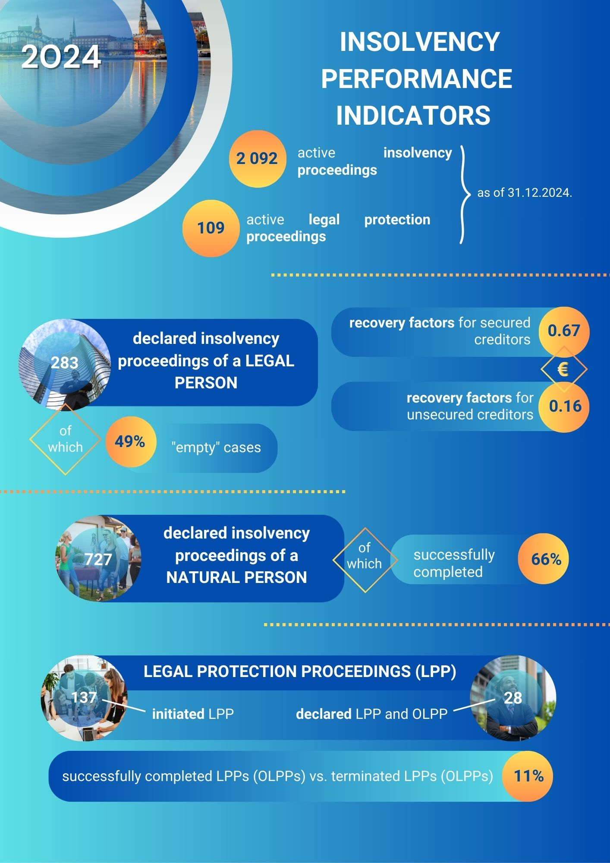

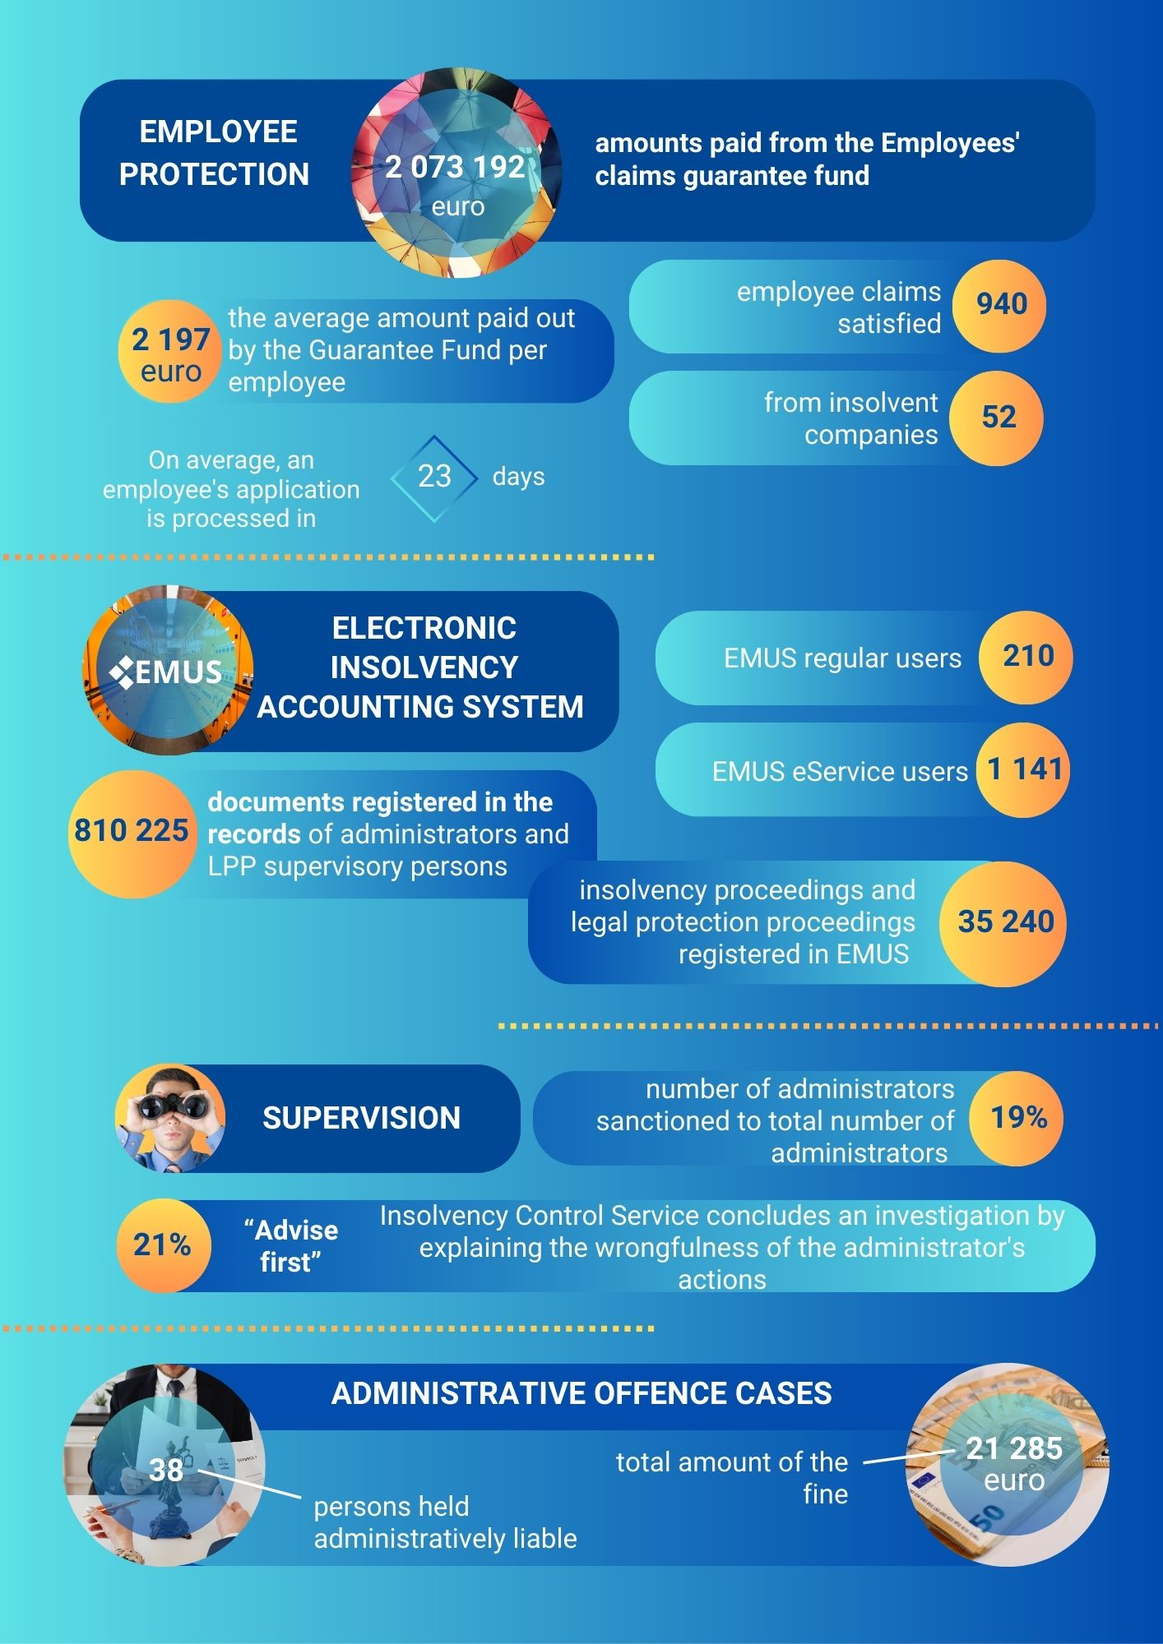

1. BASIC INFORMATION

The Insolvency Control Service is a direct administration institution under the supervision of the Minister for Justice. The Minister of Justice supervises the Insolvency Control Service through the Ministry of Justice.
The Insolvency Control Service implements the State policy in issues of legal protection proceedings (hereinafter – LPP) and insolvency proceedings. The main tasks of the Insolvency Control Service are to supervise insolvency administrators (hereinafter – administrators) and LPP supervisory persons, maintaining the Employee's claims guarantee fund (hereinafter – Guarantee Fund), and satisfying employee claims, administering the insolvency proceedings deposit (hereinafter – deposit), as well as maintaining and developing the Electronic Insolvency Accounting System (hereinafter – EMUS).

The following state budget subprograms correspond to the areas of activity of the Insolvency Control Service:
Direction of activity | Title of budget subprogram
Ensuring the lawful and effective conduct of insolvency proceedings | Insolvency proceedings management
Protecting the interests of employees in the event of employer insolvency | Employee claims guarantee fund
Ensuring the financing of insolvency proceedings | Costs of insolvency proceedings

The strategic priorities of the Insolvency Control Service for the reporting year and their objectives for the reporting year are included in the balanced scorecard:
Vision | Our knowledge and experience-based leadership is the foundation of society's belief in insolvency as a fair second chance
Mission | A professional and innovative supervisory authority that protects the public interest in the field of insolvency
Strategic priorities | 1. Strengthening the rule of law and supervision in the field of insolvency | 2. Enhancing the credibility and authority of the Insolvency Control Service | 3. Organizing work within the institution, simplifying processes and digitization | 4. Professionalism of employees, motivation for growth
Objectives | 1. Competent and open public administration institution that significantly contributes to the effective conduct of insolvency proceedings in the interests of the state and society |  | 2. Modern public administration institution that uses digital tools and e-solutions to perform its functions | 3. Professional public administration institution employing highly qualified and development-oriented people
Indicators* | 1.1. Increased proportion of preventive supervisory measures aimed at achieving compliance | 2.1. User satisfaction with EMUS operations | 3.1. Promotion of the use of EMUS e-services | 4.1. Employees' understanding of the Insolvency Control Service's mission, vision, values, priorities and objectives
Indicators* | 1.2. Number of decisions upheld within the framework of supervision | 2.2. Satisfaction with the activities of the Insolvency Control Service is increasing every year | 3.2. The number of EMUS e-service users is increasing | 4.2. Training and development measures have promoted the professional growth of employees and improved work performance
Indicators* | 1.3. Increased availability of current Insolvency Control Service opinions | 2.3. Accelerated standard decision-making | 3.3. Reduced average time taken to process an employee claims application | 4.3. Employee satisfaction with the work environment and culture
Indicators* | 1.4. Reduction in violations related to the quality of data entered into EMUS | 2.4. Promoting understanding of insolvency proceedings and key issues in the field of insolvency | 3.4. Reduced time taken to process applications for the payment of deposits | 4.4. Employee loyalty
* Key indicators of the Insolvency Control Service's operational strategy for 2021–2025. The performance of the indicators in 2024 is indicated in the relevant sections of this report.

In order to implement its strategic objectives and achieve the set performance indicators, the Insolvency Control Service has implemented the measures described in the following sections of this report.

2. FINANCIAL RESOURCES OF THE INSOLVENCY CONTROL SERVICE AND PERFORMANCE

Funds from the basic budget subprogram 06.03.00 "Insolvency proceedings management" are allocated for the implementation of the functions and tasks of the Insolvency Control Service. Within the framework of the relevant budget subprogram, the Insolvency Control Service ensures:
- resolving issues related to the official activities of the administrator;
- implementation of supervisory measures by administrators and LPP supervisory persons;
- examination of administrative offence cases;
- examination of employee claims and payment of amounts allocated to cover employee claims,
- examination of deposit applications and payment of deposits;
- EMUS development and user support;
- implementation of public measures, etc.
Based on the Law on the State Budget for 2024 and the Budget Framework for 2024, 2025 and 2026 (hereinafter – Budget Law), resources to cover expenditure in this basic budget subprogram were allocated from:
1) subsidies from general revenue;
2) revenues from paid services and other income (the paid services provided).

Funding and use of funds for subprogram 06.03.00 "Insolvency proceedings management" of the basic budget
No. | Financial indicators | Previous year (performance – cash basis), euro | During the reporting year
No. | Financial indicators | Previous year (performance – cash basis), euro | approved by law (plan with amendments), euro | execution (after cash flow), euro
1. | Financial resources to cover expenses (total) | 1 860 261 | 2 086 828 | 2 073 027
1.1. | Subsidies from general revenue | 1 860 261 | 2 041 240 | 2 041 240
1.2. | Paid services and other own revenue | 0 | 45 588 | 31 787
2. | Expenses (total) | 1 860 261 | 2 086 828 | 2 024 783
2.1. | Maintenance expenses | 1 847 370 | 2 077 170 | 2 015 150
2.1.1. | Current expenses | 1 847 370 | 2 077 170 | 2 015 150
2.1.1.1. | Remuneration | 1 643 172 | 1 876 612 | 1 842 730
2.1.1.2. | Goods and services | 204 198 | 200 558 | 172 420
2.1.2. | Subsidies, grants and social benefits | 0 | 0 | 0
2.2. | Capital expenditure | 12 891 | 9 658 | 9 633

2.1. Official activities of the administrator
According to the insolvency register data, at the end of 2024 there were 133 administrators, of whom 125 were actively working in the profession, while eight administrators had their activities restricted (i.e., suspended of official activities or suspended from the office).
In 2024, by decision of the Director of the Insolvency Control Service, 15 administrator's official activities were terminated, seven of whom were removed from their positions. Of the seven administrators, six did not apply to take the qualification exam, while one administrator was refused permission to take the qualification exam. The administrator qualification exam is a mandatory test that administrators take once every five years to prove that they still have the necessary knowledge and skills. Eight administrators were also removed at their own request.
In 2024, the Insolvency Control Service organized two administrator qualification exams in accordance with the requirements of the Insolvency Law:
- On April 25, 53 administrators took the exam. 50 administrators passed the exam, while three administrators failed.
- October 16 – 77 administrators took the exam. 74 administrators passed the exam, while three administrators failed.

2.2. Supervision of administrators and LPP supervisory persons
The aim of the supervision carried out by the Insolvency Control Service is to ensure that the actions of the administrator and the LPP supervisory persons comply with the requirements of regulatory enactments, and to prevent insolvency proceedings from being used for the legalisation of criminally obtained funds and the financing of terrorism and proliferation, as well as for the circumvention and violation of international and national sanctions, thereby promoting the legality and effectiveness of insolvency proceedings and, consequently, contributing to the creation of an attractive business environment and attracting investment. In performing its supervisory function, the Insolvency Control Service ensures the protection of creditors' interests by assessing the legality of the insolvency process and the actions of the administrator, identifying possible violations and preventing unfair practices, thus promoting a fair and transparent insolvency process. In 2024, the total amount of claims recognised by creditors in insolvency proceedings examined only as part of in-depth inspections reached 55.6 million euro.

2.2.1. Supervision under the Insolvency Law
During its supervision activities in 2024, the Insolvency Control Service identified violations in 19 % of all administrators. Compared to 2023, this figure has decreased by 5 %, when violations were identified in 24 % of administrators. The Insolvency Control Service implements risk-based supervision and preventive measures, the impact of which can be seen in the supervision results – significant violations or abuse of powers were found only in isolated cases. The reduction in the number of violations is also related to the planned supervision carried out by the institution, as well as the application of the "Advise first" principle. The "Advise first" principle is implemented by developing informative materials, circulars, and conducting informative events. Similarly, starting from 1 May 2024, the Insolvency Control Service publishes on its website the decisions taken by the Insolvency Control Service and the Commission of Disciplinary Matters, which assesses the actions of administrators and LPP supervisory persons. The purpose of publishing these decisions is to inform the public about current practices in the supervision of administrators and LPP supervisory persons and in disciplinary cases, promote a common understanding and uniform application of regulatory acts governing the insolvency sector, transparency of the actions of administrators as public officials, and transparency of the activities of the Insolvency Control Service.
In total, in 2024, the Insolvency Control Service carried out 155 planned and unplanned inspections. 96 inspections were completed without finding any violations, 24 inspections were completed with a decision on the finding of violations by the administrator or the LPP supervisory person, and three inspections were completed with the submission of an application to the court. The Insolvency Control Service submits an application to the court to assess the issue of removal of the administrator or the LPP supervisory person if significant violations of regulatory enactments have been committed in the process, causing damage to the parties involved in the process, and these are incompatible with the further performance of duties in the insolvency process or LPP. Similarly, in 2024, in accordance with the "Advise first" principle, the Insolvency Control Service continued to apply a preventive supervisory tool within the framework of its inspections – explanation of misconduct. In total, the Insolvency Control Service used this tool 32 times in 2024.

2.2.1.1. Planned (risk-based) inspections
The wrongness of an action explained
Applications for suspension
Decisions recognising violations

Of the 155 inspections carried out in 2024, the breakdown of supervisory measures by type was as follows:
● 18 on-site in-depth inspections of the practices of administrators;
● 18 off-site in-depth inspections on the conduct of administrators in legal persons proceedings;
● 87 thematic off-site inspections, which examined a specific particular aspect of the insolvency proceedings or LPPs;
● 32 investigations, which were initiated on the basis of information received from parties involved in the proceedings or third parties.
In addition to the thematic inspections mentioned above, the Insolvency Control Service has also carried out off-site horizontal inspections, which have examined:
● whether administrators have entered information about their civil liability insurance in accordance with regulatory requirements. A total of 136 administrators were checked during the inspection;
● whether the data necessary for the calculation of the insolvency sector's performance indicators (creditors' claims admitted, creditors' claims settled, funds raised, costs) are entered in the EMUS process card. The inspections covered 141 insolvency proceedings.
In 2024, the number of violations detected by administrators in the context of planned inspection activities has decreased. The Insolvency Control Service, when carrying out inspections, adopted 14 decisions on the recognition of irregularities in the activities of administrators, in total 48 irregularities. On the initiative of the Insolvency Control Service regarding violations of regulatory acts, two administrators were removed from a particular insolvency proceeding. In two cases, the Insolvency Control Service has reported matters to the Corruption Prevention and Combating Bureau after finding evidence of criminal offences. Meanwhile, 30 inspections ended with administrators being given explanations about their wrongdoing.
In 2024, the most common violations were related to failure to provide information to people involved in the process, incomplete data and document entry into EMUS, assessment of creditors' claims, and assessment of transactions.

2.2.1.2. Complaint review
A complaint about the actions of an administrator or LPP supervisory person is an important legal protection tool for creditors in insolvency proceedings.

Comparing the complaint handling statistics for 2024 and 2023, there is an increase in both the number of complaints lodged and the number of violations admitted. This is partly due to the fact that there is still a tendency to file several complaints against the same administrator in the same insolvency proceedings. In addition, some of the complaints are about increasingly legally complex (non-standard) situations, thus requiring the involvement of the Insolvency Control Service.
total complaints

Assessing the nature of the complaints, it can be concluded that the persons involved in the insolvency proceedings most often complain about the administrator's conduct related to the failure to provide information on the insolvency proceedings or its incomplete provision, the failure to assess creditors' claims, as well as the failure to survey, recovery and unjustified alienation of the debtor's property. However, when assessing the nature of the violations detected in the actions of the administrators, it can be concluded that the most frequent violations detected by the Insolvency Control Service were in relation to the identification/acquisition/inventory of the debtor's assets, assessment of creditors' claims, failure to respond to the parties involved in the insolvency proceedings, calculation and payment of the costs of the insolvency proceedings, as well as in relation to the evaluation of the debtor's transactions.
Example: in the course of the examination of a complaint concerning the administrator's conduct in relation to the provision of information, it was established that the administrator, at the time of the adoption of the decision on the complaint, had still not provided the complainant with a reply to the complainant's requests for information on the conduct of the insolvency proceedings of the debtor. It is therefore concluded that the administrator has not complied with the requirements of Article 6 (7), Article 26 (2) and (3) (2) of the Insolvency Law. The decision imposes a legal obligation on the administrator to reply to the complainant without delay, informing him of the progress of the insolvency proceedings of the debtor.

The Insolvency Control Service, having examined the complaints received in 2024, in one case found significant irregularities in the administrator's conduct, which resulted in an application to the court for the administrator's removal from his/her duties in the insolvency proceedings in question.

2.2.1.3. Supervision under the Prevention Law and Sanction Law
Preventing money laundering and controlling sanctions are essential to protect the integrity of the country's financial system, strengthen public confidence in the rule of law and ensure compliance with international security requirements. Ensuring that administrators comply with the requirements of the Prevention Law and the Sanctions Law, and that the Insolvency Service monitors compliance with these requirements, contributes to the achievement of these objectives.

The Insolvency Supervisory Service carried out 27 inspections in 2024 as part of its supervision under the Prevention Law. 22 inspections were carried out as off-site inspections and five as on-site inspections. In addition to inspections, the Insolvency Control Service also conducts explanatory work to ensure compliance with the requirements. In order to facilitate the administrator's activities, the Insolvency Control Service has also enabled administrators to check the sanction lists centrally in the administrators' working environment - EMUS.
The wrongness of an action explained
Decisions imposing fines

Violations detected leading to a proposal for sanctions against the administrator:
1) no identification of the client;
2) failure to verify the origin of the client's funds;
3) ate and incomplete verification of the client in the sanctions lists;
4) delayed client due diligence.
Common deficiencies that allow the administrator to explain the wrongness of the action and give a deadline to remedy the non-compliance:
1) weaknesses in the internal control system and professional risk assessment;
2) failure to update the internal control framework and professional risk assessment in a timely manner;
3) deficiencies in the client risk assessment procedure;
4) deficiencies in the documentation of client research;
5) delayed completion of certain activities within the scope of client research.

Example: the following case was found during an inspection in relation to deficiencies in the identification of natural persons. The administrator sold the debtor's assets to a natural person by identifying the buyer and meeting him in person. The administrator had not documented the steps taken in the face-to-face identification process, i.e. had not obtained a copy of the identity document and had not obtained a printout of the verification of the identity document in the register of invalid documents.
Compared to 2023, there has been a decrease in the number of sanctions imposed. In 2024, the Insolvency Control Service, having independently detected a breach of the Prevention Law by an administrator, imposed sanctions for breaches of the Prevention Law on two administrators in the amount of 400 euro (the total amount of the fine imposed).

Strategy indicators for monitoring in 2024.
Indicator | Target indicator value in 2025 | Performance in 2024
1.1 Increase in the share of preventive supervision measures aimed at achieving compliance | 50 %  supervision (Insolvency Law)  50 %  supervision (Prevention Law) | 57 %  supervision (Insolvency Law)  83 %  supervision (Prevention Law)
1.2. Number of decisions upheld under supervision | 90 % | 96 %
1.3. Increased availability of up-to-date views from the Insolvency Control Service | 80 % | 100 %
Indicator | Target indicator value in 2024 | Performance in 2024
1.4. Reduction in the number of infringements related to the quality of data entered into EMUS | ≤ 13 %  of cases where a letter of discrepancy was sent after the check | 32 %  of cases where a letter of discrepancy was sent after the check

2.3. Administrative offence case review
In administrative offence cases for breach of the rules on insolvency proceedings and the LPP, in 2024, the Insolvency Control Service initiated 42 administrative offence proceedings and held 38 natural persons administratively liable, 9 of whom were also subject to an additional penalty - a deprivation of rights from holding certain positions in commercial companies.
In 2024, the above figures have decreased compared to 2023, with 60 administrative offence proceedings initiated in 2023. All the administrative offence proceedings opened in 2024 were against the debtor's representative in the insolvency proceedings of a legal person. 55 natural persons were held liable, 23 of whom were subject to an additional penalty to exclude unscrupulous persons from commercial circulation for a specified period of time. In the cases examined, there is a tendency for the members of executive board of commercial companies to deliberately avoid liability for the failure to hand over documents and the consequent damages (both administrative and civil) suffered by the trader through various legal solutions
Undertaken processes
Decisions imposing a penalty
Additional penalties applied

In 2024, the amount of fines imposed by the Insolvency Control Service under the administrative offence proceedings decreased to 21 285 euro, compared to 33 890 euro in 2023, but the amount of fines collected increased to 14 543 euro, compared to 11 415 euro in 2023. The average fine per person has also decreased, to 560 euro, from 616 euro in 2023. In determining the amount of the fine, the Insolvency Control Service considers various circumstances, such as whether the person has remedied the infringement, is cooperating with the administrator and the institution, has circumstances affecting his/her financial situation, etc.

The Director of the Insolvency Control Service, as a higher official within the meaning of the Law on Administrative Liability, has taken six decisions in 2024 when considering complaints against decisions taken by officials of the Insolvency Control Service in administrative offence cases. Of these, in three cases the complaint was found not to have been lodged as the deadline for lodging the complaint was missed, in two cases the complaint was dismissed and in one case the Insolvency Control Service modified the administrative penalty initially imposed.
Whereas in 2023, five decisions were taken on complaints, in one case modifying the administrative penalty imposed. Overall, the decline in the number of complaints is partly due to the gradual consolidation of case law, making it possible to prepare decisions based on case law, thus reducing the chances of complainants having decisions overturned or amended.
Of the six decisions taken by a higher official of the Insolvency Control Service in 2024, three have been appealed to the courts. Similarly, of the five decisions taken in 2023, three were appealed to the courts. In 2024, the courts have adopted four decisions on the decisions of the Insolvency Control Service in administrative offence cases (including decisions adopted before 2024), the same as in 2023. No decision of the Insolvency Control Service has been amended or annulled by court decisions in 2024.

2.4. Examination of employee claims and payment of amounts allocated to cover employee claims
In accordance with the Law on the Protection of Employees in the Event of the Insolvency of Employer, the Insolvency Control Service settles employees' claims from the Guarantee Fund – subprogram 06.04.00 "Employee claims guarantee fund" of the core budget. The Guarantee Fund is funded by a share of the State entrepreneurial risk fee and by financial resources recovered by way of recourse.

Funding and use of subprogram 06.04.00 "Employee claims guarantee fund" of the basic budget
No. | Financial indicators | Previous year (performance – cash basis), euro | During the reporting year
No. | Financial indicators | Previous year (performance – cash basis), euro | approved by law (plan with amendments), euro | execution (after cash flow), euro
1. | Financial resources to cover expenses (total) | 2 607 033 | 2 173 014 |  | 2 485 520
1.1. | Subsidies form general revenue | 0 | 0 |  | 0
1.2. | Paid services and other own revenue | 2 607 033 | 2 173 014 |  | 2 485 520
2. | Expenses (total) | 1 269 471 | 3 381 625 |  | 2 073 192
2.1. | Maintenance expenses | 1 269 471 | 3 381 625 |  | 2 073 192
2.1.1. | Current expenses | 531 259 | 1 437 766 |  | 838 496
2.1.1.1. | Remuneration | 0 | 0 |  | 0
2.1.1.2. | Goods and services | 531 259 | 1 437 766 |  | 838 496
2.1.2 | Subsidies, grants and social benefits | 738 212 | 1 943 859 |  | 1 234 696

In 2024, the Guarantee Fund disbursed a total of 2 073 192 euro, the highest amount of Guarantee Fund disbursements in the last ten years, since 2014:
1) 1 226 250 euro transferred to the accounts of the insolvent employer's employees;
2) 838 496 euro transferred to the Single Tax Account;
3) 6 591 euro to cover the administrator's remuneration for the 338 employees whose employee claims have been covered by the Guarantee Fund (19.50 euro per employee);
4) 1 855 euro to cover the costs of insolvency proceedings where the insolvency proceedings are brought by an employee who has been exempted from the insolvency deposit.
In 2024, the Guarantee Fund disbursed funds to meet the claims of 940 employees of 52 insolvent companies, an increase of 34 % compared to 2023. The average amount allocated per employee to cover claims in 2024 was 2 197 euro, an increase of 22 % compared to 2023.
The average time taken to process an employee's claim (and, consequently, the money transferred to the employee's account after the decision) depends on the quality of the documents submitted by the debtor-employer and the information available to the administrator. In 2024, applications for employee claims were dealt with on average within 23 days.

Dynamics of the indicators on the use of Guarantee Fund
Indicator | Guarantee Fund disbursements*, euro | Number of satisfied employees | Amount of funds recovered, euro | Average gross amount covered per employee**, euro | Average time taken to process an application***, days
2024 | 2 073 192 | 940 | 502 506 | 2 197 | 23
2023 | 1 269 471 | 699 | 617 107 | 1 805 | 19
2022 | 1 361 582 | 737 | 408 142 | 1 842 | 24
2021 | 589 526 | 421 | 413 627 | 1 359 | 47
* incl. administrators' remuneration and deposit;
** incl. employer's share of the employer's rate of payments of the mandatory State social insurance contributions;
*** for the settlement of employees' claims.

Major employers whose employees' claims are covered by the Insolvency Control Service in 2024:
Major insolvent employers | Number of employees | Amount paid, euro
MAS "CEĻU PĀRVALDE" | 343 | 809 056
MSIA "OSTAS CELTNIEKS" | 125 | 330 493
MSIA "FORTA PREFAB" | 92 | 276 404
MSIA "AURORA BALTIKA" | 49 | 89 809
MAS "ARTA - F" | 42 | 73 984

On 1 July 2024, amendments to Section 73 (4¹) of the Insolvency Law entered into force, which provides that the creditors' claim is merged with the employees' claim, so that the employee can submit all the necessary information in one place, immediately providing, in addition to the information to be provided in the creditors' claim, the information that was previously required to be provided only in the employees' claim form.

The creditor's claim will also be the employee's claim and will in itself entitle the employee to the satisfaction of the employee's claims out of the Guarantee Fund, relieving the employee of the burden of completing two documents.
In exercising the Insolvency Control Service's creditor's right to reimbursement of funds granted by the Insolvency Control Service and paid from the Guarantee Fund to satisfy employees' claims, the Insolvency Control Service attended 29 creditors' meetings in 2024. In the course of the examination of the received documents, the Insolvency Control Service, as a creditor, had grounds to raise objections 31 times in 2024 in the insolvency proceedings of a legal person on issues of importance in the insolvency proceedings (the schedule of costs and the plan for settling the claims of creditors, the plan for the sale of debtor's property and amendments thereto, the execution of the plan for settling the claims of creditors, the plan of measures of LPP, as well as on notifications made in accordance with Article 81 of the Insolvency Law, incl., (e.g. announcements of the intention to enter into a composition agreement, write-off or assignment of receivables, etc.) to ensure an efficient and lawful insolvency proceedings.

The Insolvency Control Service attended 29 creditors' meetings in 2024. In the course of the examination of the received documents, the Insolvency Control Service, as a creditor, had grounds to raise objections 31 times in 2024 in the insolvency proceedings of a legal person on issues of importance in the insolvency proceedings (the schedule of costs and the plan for settling the claims of creditors, the plan for the sale of debtor's property and amendments thereto, the execution of the plan for settling the claims of creditors, the plan of measures of LPP, as well as on notifications made in accordance with Article 81 of the Insolvency Law, incl., (e.g. announcements of the intention to enter into a composition agreement, write-off or assignment of receivables, etc.) to ensure an efficient and lawful insolvency proceedings.
attended creditors' meetings
objections, number
Given that employees whose employer has been declared insolvent in insolvency proceedings of a natural person (including an economic activity operator) opened after 14 September 2023 are also eligible for payment from the Guarantee Fund, the exercise of creditors' rights is also carried out in insolvency proceedings of a natural person. In 2024, the Insolvency Control Service started to exercise creditors' rights in one insolvency proceeding of a natural person.
During the insolvency proceedings, the administrators recovered and transferred back to the State budget funds amounting to 502 506 euro. The implementation of the Guarantee Fund in 2024 was 61 % of the planned level (total planned expenditure of 3 381 625 euro).

2.5. Examination of deposit applications and payment of deposits
The insolvency proceedings are financed by the insolvency deposit, the payment of which is based on a decision taken by the Insolvency Control Service. In 2024, the Insolvency Control Service adopted 284 decisions on the payment of the insolvency deposit of a legal person for a total amount of 344 324 euro, of which 159 decisions for a total amount of 213 980 euro were adopted under the simplified procedure and 1 429 decisions on the payment of the insolvency deposit of a natural person for a total amount of 973 080 euro, of which 1 262 decisions for a total amount of 864 euro were adopted under the simplified procedure.
If the administrator or the creditor misses the deadlines for submission of applications for payment of the deposit or if the application for insolvency proceedings of the legal person was unfounded or knowingly false, the Insolvency Control Service transfers the deposit to the state budget revenue. In 2024, deposits of 63 133 euro were transferred to the state budget revenue for insolvency proceedings of a legal person.

Data on deposit dynamics
Indicator | Number of decisions taken on the payment of insolvency deposits for legal and natural persons | Decisions taken on the payment of insolvency deposits for legal and natural persons, amount in euro | Average time taken to process an application for insolvency deposit for legal and natural persons, days | Transfer of legal person's insolvency deposit to state budget revenue, amount
2024 | 1 713 | 1 317 404 | 3 | 63 133
2023 | 1 797 | 1 157 365 | 3 | 119 616
2022 | 1 871 | 1 109 900 | 3 | 52 506
2021 | 2 065 | 1 131 885 | 3 | 52 286

Strategy indicators on employee claims and deposit payout met in 2024
Indicator | Target indicator value in 2025 | Performance in 2024
3.3. Reduced average time taken to process employee claims | On average 35 days | On average 23 days
3.4. Reduced processing time for deposit applications | On average 10 days | On average 3 days

2.6. Administrating the costs of insolvency proceedings
According to the information report (26 October 2021) on the transfer of documents from insolvency proceedings of legal persons to the archives free of charge, the costs incurred by the Latvian National Archives in transferring the debtor's documents to the State Archives are to be compensated by an annual transfer payment from the Insolvency Control Service. This payment is made from the subprogram 06.05.00 "Costs of insolvency proceedings" of the basic budget. The resources available for 2024 to cover expenditure in this subprogram were allocated from the use of surpluses from previous years and from funds recovered by way of recourse.

Funding and use of subprogram 06.05.00 "Costs of insolvency proceedings" of the basic budget
No. | Financial indicators | Previous year (performance – cash basis), euro | During the reporting year
No. | Financial indicators | Previous year (performance – cash basis), euro | approved by law (plan with amendments), euro | execution (after cash flow), euro
1. | Financial resources to cover expenses (total) | 0 | 50 |  | 356
1.1. | Subsidies | 0 | 0 |  | 0
1.2. | Paid services and other own revenue | 0 | 50 |  | 356
2. | Expenses (total) | 0 | 101 422 |  | 0
2.1. | Maintenance expenses | 0 | 101 422 |  | 0
2.1.1. | Current expenses | 0 | 0 |  | 0
2.1.1.1. | Remuneration | 0 | 0 |  | 0
2.1.2. | Subsidies, grants and social benefits | 0 | 1 422 |  | 0
2.1.3. | Transfer | 0 | 100 000 |  | 0

In 2022, the first transfer payment of 100 000 euro was made. As 60 900 euro of this amount remained for 2024, no new transfer payment was made in 2024. The calculations have already been based on the prices indicated in the information report of 9 January 2024. As of 1 January 2025, the balance of the transfer is 27 196 euro.

2.7. EMUS development and user support
One of the priorities of the Insolvency Control Service's operational strategy for 2021 - 2025 is the digitization of processes, therefore one of the tasks of the institution in 2024 has been the maintenance, improvement and development of EMUS.
Improvements made in 2024 focus on improving data quality, using a secure and transparent email solution, adapting to changes in legislation and improving user-friendliness, in particular as regards the usability of the insolvency costs section.
To make EMUS an effective and sustainable tool, a working group has been set up to focus on improving EMUS, developing innovative solutions and identifying user needs.

Strategy indicators for EMUS 2024
Indicator | Target indicator value in 2025 | Performance in 2024
2.1. User satisfaction with EMUS | 80 % | 81 %
3.1. Promoting the use of the EMUS e-service | 4  informative events* per year | 4  informative events
Indicator | Target indicator value in 2024 | Performance in 2024
3.2. EMUS e-service users increase | 1 541 users  4 055 sessions | 1 142 users  3 601 sessions
* Includes both organised outreach events, produced informative material and social media posts, aimed at promoting the EMUS e-service and encouraging its use.

2.8. Services provided by the Insolvency Control Service, improvements in ensuring the availability and quality of services
The "Service Environment Improvement Plan 2024-2027" (hereinafter – the Improvement Plan), including its Annex 2 "Work Plan", has been established and approved by the Cabinet of Ministers' Regulation No 444 of 4 June 2024 to implement the Improvement Plan 2024-2027.
The service management objective is: "Satisfied service users", while the Improvement Plan implementation objective is: "Services fully managed". The work plan sets out service management-related actions to be undertaken by public administrations in the period 2024 - 2027 and beyond.
Insolvency Control Service in 2024:
- staff involved in service management participated in training organised by the Ministry of Smart Administration and Regional Development - both on service management policy and on setting up service management implementation teams, as well as on assessing the current state of service and service management and developing improvement plans;
- the list of services of the Insolvency Control Service has been defined in line with the new service management policy:

Services | Payment of unpaid wages to an employee by an insolvent employer
Services | Payment of the insolvency deposit
Services | Digital service for administrators, LPP supervisory persons, creditors, debtor's representatives and the debtor
Services | Ensuring the functioning of administrators' official activities
Services | Payment of deposited funds to the creditor

- a service management implementation team has been established, i.e. a service package manager, a resource package manager and service managers - those who will be most active in developing the service environment in the future;
- work started on the institution's service management and service evaluation and improvement plans.
The services of the Insolvency Control Service, their provision and management can be found on www.latvija.lv.

Meeting the strategy's indicators for service delivery in 2024
Indicator | Target indicator value in 2025 | Performance in 2024
2.3. Expedited standard decision-making (deposit decisions) | Accelerated by at least 20 % of the base value | Accelerated by 40 %
2.3. Accelerated standard decision-making (decisions on employee claims) | Accelerated by at least 20 % of the base value | Accelerated by 50 %

3. STAFF OF THE INSOLVENCY CONTROL SERVICE

The Insolvency Control Service has undergone a structural change in 2024 with the creation of two divisions in the First Supervision Department - the Supervision Division and the EMUS Division. The post of Director of Internal Control and Risk Management was created. 2024 started with 66 posts and in July 2024 three unfunded posts were transferred to the Department of Justice. At the end of 2024, the Insolvency Control Service had 63 posts, of which 54 were state officials and nine employees s.
and more
Staff and turnover characteristics of the Insolvency Control Service
Indicator | Number/level
Actual average number of employees in 2024:  incl. officials  incl. employees | 53  44  9
Number of persons with whom an employment relationship or a civil service relationship has been established | 11
Number of persons with whom an employment relationship or a civil service relationship has been terminated | 8
Staff turnover rate (annual)* | 15,17
* Staff turnover rate = number of redundancies per year/average number of employees per year x 100 %.

Insolvency Control Service employees by education
Education | Number of employees*
Higher education  incl. Master's degree  incl. obtaining upper secondary education | 49  38  1
Secondary (specialised secondary) education | 5
*year-end information, excluding long-term absentees

Professionalism, development and motivation of the Insolvency Control Service staff is one of the priorities set out in the operational strategy, which is why in 2024 knowledge was acquired on the role and possibilities of digitalization and artificial intelligence, as well as on communicating in clear and plain (simple) language. We also covered service management requirements, cyber hygiene and data protection skills, as well as current developments in international sanctions and other training.

Achievement of the HR Strategy indicators in 2024
Indicator | Target indicator value in 2025 | Performance in 2024
4.1. Employees' understanding of Insolvency Control Service mission, vision, values, priorities and goals | 90 %  employed | 88 %  employed
4.2. Training and development activities have contributed to the professional development of employees and improved performance | At least 80 % of employees have a positive annual evaluation | 82 %  positive evaluation by employees
4.3. Employee satisfaction with the working environment and culture | 80 % | 90 %
4.4. Employee loyalty | 80 % | 100 %

4. COMMUNICATION WITH THE PUBLIC

4.1. Communication channels, number of users and profile
In order to inform the public on topical issues related to insolvency and to raise people's awareness of the activities and services of the Insolvency Control Service, the Insolvency Control Service uses six communication channels - the website www.mkd.gov.lv, social media accounts - Twitter, Facebook, Linkedin, Instagram and Youtube. To better identify the needs of the public, the service checks data on a quarterly basis using the google analytics data tool, where it focuses on the number of users and the share of new users, as well as the most frequently searched and used content.

In 2024, 29 000 users visited the Insolvency Control Service website, of which 28 000 were new visitors, i.e. 96 %. This means that the profile of a visitor to the website could be characterised as inexperienced, as most visitors are dealing with insolvency issues for the first time. These statistics have been observed since the use of the google analytics tool by the service, i.e. from 2020.
new users

The news, visuals and video explanations published on the website are published on all the Insolvency Control Service's social media accounts, tailored to the requirements of each social account. Twitter and Facebook are used as news channels, the Instagram account is used more as a business card profile, publishing topical stories. On Linkedin, the Insolvency Service appeals more to a professional and international audience, while the YouTube channel offers explanatory videos and training to anyone, accessible only to a specific audience.
The Insolvency Control Service does not use paid services to advertise its accounts on social networks, so the increase in followers/subscribers is a naturally occurring indicator, determined by the popularity of the social network in question, the quality of the content and the use of communication tools to help search engines find the content they need.

Data on followers/subscribers on the Insolvency Control Service's social network accounts
Social media account | Year when communication started | Number of followers/subscribers |  | % increase or decrease in followers/subscribers
Social media account | Year when communication started | 2023 | 2024 | % increase or decrease in followers/subscribers
Twitter | 2015 | 620 | 631 | + 1 %
Facebook | 2020 | 616 | 655 | + 6 %
Linkedin | 2021 | 92 | 130 | + 41 %
Instagram | 2022 | 37 | 72 | + 94 %
Youtube | 2020 | 35 | 36 | + 2 %

4.2. Public information and education measures
Based on data on the most searched content on the Service's website, in 2024 the Insolvency Control Service set as a communication priority the education of the public about the insolvency process of a natural person, i.e. how to start it, what documentation is required, how much the process costs, etc. Also, considering that the Insolvency Control Service's audience encounters insolvency issues for the first time in 96 % of cases, in 2024 the service also ensured that the developed materials and information were in plain language.
In 2024, the Insolvency Control Service reported:
- the latest explanations and findings;
- anonymized decisions (see point 2 of this chapter);
- the amount of the State entrepreneurial risk fee;
- EMUS development and new functionalities;
- monitoring news and results;
- insolvency performance indicators, etc.
In August 2024, a magazine dedicated to the field of insolvency, "Jurista vārds", was published. It publishes articles and opinions by experts from the Insolvency Control Service on the most important issues in this field - both on changes in the law and practical examples and problems faced by participants in the process and professionals in the field.
During the reporting period, the following informative materials were developed and published, intended for everyone interested, not only insolvency professionals:
1) Explanatory video materials prepared by the Insolvency Control Service (in cooperation with the Latvian Association of Insolvency Administrators, the Financial Industry Association and the Consumer Rights Protection Center) on the insolvency process of a natural person:
- How to initiate insolvency proceedings of a natural person;
- Obligations of a debtor during insolvency proceedings;
- About legal service providers who promise to release you from debt obligations;
- How insolvency proceedings affect a person's credit history;
2) Methodological instructions for using the Electronic Insolvency Accounting System e-service and entering information;
3) Explanations and findings of the Insolvency Control Service December 2023 – June 2024;
4) Explanations and findings of the Insolvency Control Service July 2024 – November 2024;
5) Infographic: "Payment or refund of a deposit in the insolvency proceedings of a natural person".

4.3. Informative measures and materials for administrators and LPP supervisory persons
As from 1 May 2024, decisions adopted by the Insolvency Control Service and the Commission of Disciplinary Matters assessing the conduct of administrators and LPP supervisory persons shall be published on the website of the Insolvency Control Service. The purpose of publishing the decisions is to inform the public about the current practice in cases of supervision and disciplinary offences of administrators and LPP supervisory persons, to promote common understanding and uniform practice in the application of laws and regulations governing the insolvency sector, transparency of the conduct of the administrator as a public official and transparency of the activities of the Insolvency Control Service.
Clarification of compliance requirements is essential to achieve the supervision objective. In order to promote administrators' understanding of the application of the legal provisions, the Insolvency Control Service has developed informative materials and organised the following events for administrators and LPP supervisory persons in 2024:
1. 16 December 2024 online informative event "On supervision results";
2. 24 October 2024 online informative event on employee claims and EMUS updates;
3. 20 June 2024 online seminar "Legal aspects of challenging transactions";
4. 6 June 2024 online seminar "European Digital Tools for Insolvency";
5. 15 May 2024 online informative event "On international and national sanctions enforcement issues and the application of the principle of openness in insolvency proceedings";
6. 30 April 2024 online seminar "Formal restructuring in Latvia - available solutions and latest developments";
7. 16 April 2024 online seminar on "Basic principles of personal data protection and their practical application";
8. Informative material: "On ensuring the principle of transparency in insolvency proceedings";
9. Infographic: What you need to know if you want to be a LPP supervisory person;
10. Infographic: Instructions for administrators - what to do if an employee submits information on employee claims outside the Electronic Insolvency Accounting System.

4.4. Public assessment of the quality of the work of the Insolvency Control Service
The Insolvency Control Service appreciates that it has a large following on social networks, and statistics show that people are actively reading, are interested in insolvency, in their rights and obligations, and are willing to share what they read. The active cooperation between journalists and LV portal with the Insolvency Control Service also shows that the public is interested and that the opinion of the Insolvency Control Service is important. Currently, every interested person and reader can express his or her opinion on the topicality of what he or she has read and on the activities of the Insolvency Control Service, both on the publications published on media pages and on the articles posted on the social network accounts of the Insolvency Control Service.
Between 4 and 16 April 2025, the Insolvency Service carried out a survey to find out administrators' views on cooperation with the Insolvency Control Service in 2024.
The survey shows that 79 % of administrators rate their cooperation with the Insolvency Control Service as positive or rather positive. Most administrators noted an improvement in communication (especially on EMUS issues), a quicker response to problems and a consultative rather than punitive approach. The most positive comments from administrators were the procedure for handling deposit applications and deposit disbursements, as well as the off-site inspections carried out under the supervision of the Insolvency Control Service. The majority of respondents also stated that they were satisfied with the handling of complaints, indicating that the Insolvency Control Service's decisions resulting from the handling of complaints are objective and well-founded.
At the same time, the administrators consider that there is potential for further streamlining of processes, including simplifying certain administrative requirements. Several respondents pointed to the need to change the regulatory framework for the payment of the deposit, so that most of the total amount of the deposit in the insolvency proceedings of a natural person would be paid after the bankruptcy proceedings have been completed. There were also a number of suggestions for improving EMUS , such as the creation of a frequently asked questions section.
The Insolvency Control Service appreciates the feedback. All suggestions will be carefully assessed in terms of their usefulness, compliance with the regulatory framework, available budget and technical capacity, and put into practice as far as possible. As part of the work on the implementation of the proposals, a solution to the procedure for the payment of the deposit in the insolvency proceedings of a natural person, which provides that 80 % of the total amount of the deposit is paid upon completion of the bankruptcy proceedings and the remaining 20 % upon completion of the discharge procedure, has been included in the draft law "Amendments to the Insolvency Law" No. 24-TA-1137. At the same time, the Insolvency Control Service has addressed the Ministry of Justice with a proposal to include in the said draft law proposals providing that a creditors' meeting need not be convened if the costs exceeding 5 % of the value of the debtor's assets result from legislation and/or court judgment. Work is also underway to introduce several other proposals.
The survey helps to identify priority areas for improvement and to improve cooperation with administrators in the future.

Communication strategy indicators met in 2024
Indicator | Target indicator value in 2024 | Performance in 2024
2.2. Satisfaction with the functioning of the Insolvency Control Service increases year on year | 88 %  administrators rate the cooperation with the Insolvency Control Service as positive or rather positive | 79 %  administrators rate the cooperation with the Insolvency Control Service as positive or rather positive
2.4. Awareness raised on insolvency proceedings and relevant insolvency issues | 5  informative events | organized  7  informative events

4.5. Cooperation with the non-governmental sector
During the reporting period, the Insolvency Control Service pursued targeted cooperation with representatives of the non-governmental sector, ensuring a regular and multifaceted dialogue on insolvency developments and topical issues:
1) On 27 March 2024, the Advisory Council on Insolvency matters met. The Council's activities aim, inter alia, to contribute to the development and implementation of policy on insolvency issues and is composed of a few non-governmental organisations;
2) 8 May 2024 meeting with representatives of the Foreign Investors Council in Latvia;
3) 27 May 2024 meeting with representatives of the Finance Latvia Association;
4) 28 May 2024 meeting with representatives of the Employers' Confederation of Latvia;
5) 30 May 2024 meeting with representatives of the Latvian Chamber of Commerce and Industry;
6) 4 June 2024 meeting with representatives of the Latvian Confederation of Free Trade Union;
7) 22 February 2024 and 10 October 2024 meetings with representatives of the Latvian Association of Insolvency Administrators.
Cooperation with these organisations - including professional associations, employers' and employees' representatives, as well as foreign investors' representatives - facilitated exchanges of views, strengthened mutual understanding and contributed to more effective implementation of insolvency policies. This approach demonstrates the Insolvency control Service's openness to public involvement and its commitment to sustainable and inclusive governance.

5. iNSOLVENCY INDUSTRY UPDATES

The Insolvency Service has compiled a set of performance indicators for the insolvency sector for 2024. Data collection and analysis are essential to objectively assess trends in the sector, identify issues of concern and make informed decisions to improve policy and supervision.
In 2024, the number of insolvency proceedings declared against legal persons increases by 17 % compared to 2023. Last year, 368 legal person insolvency proceedings were opened, and 283 legal person insolvency proceedings were declared. According to Lursoft data, the sectors in which legal person insolvency proceedings are most likely to be declared in 2024 are:
1) construction of residential and non-residential buildings (NACE 41.2) – 6,4 %;
2) restaurant and mobile catering services (NACE 56.1) – 5,7 %;
3) retail sale of other goods in specialised stores (NACE 47.7) – 4,4 %;
4) road freight transport (NACE 49.4) – 4,0 %;
5) manufacture of wood, cork, straw and plaiting materials (NACE 16.2) – 3 %;
6) other specialised wholesale trade (NACE 46.7) – 2,7% .
Taking into account these sectors, the increase in the number of insolvencies may be related to the effects of the Covid-19 pandemic, the increase in interest rates on loans, the geopolitical changes that affected Latvia as an export-oriented country.
As for the 23 % of cases where the court did not declare insolvency proceedings, the data show that the most frequent reason for the court not declaring insolvency proceedings is that after the insolvency petition was filed with the court, the parties agreed on the payment of the debt, so the creditor had withdrawn the insolvency application.
Compared to 2023, the number of LPPs declared increased by 12 % last year: 28 LPPs were declared in 2024 and 25 in 2023. Last year, 137 cases were initiated, compared to 90 in 2023. This means that entrepreneurs are increasingly opting for a statutory procedure - LPP - to save their businesses from financial difficulties. However, the number of cases where the court has ordered the implementation of an LPP after a case has been opened has fallen, in most cases due to creditors' refusal to agree on a plan of measures of LPP.
In 2024, the number of natural person insolvency proceedings has slightly decreased by only 1 %, i.e. 727 insolvency proceedings have been opened, compared to 737 in 2023. This decrease is most likely due, among other things, to an increase in the national minimum wage, with a consequent increase in the deposit for natural person insolvency proceedings, as a deposit of two minimum wages is required to initiate natural person insolvency proceedings.

Absolute dynamics of insolvency proceedings and LPPs
Indicator | 2021 | 2022 | 2023 | 2024
Legal persons insolvency proceedings initiated (including on creditors' applications) | 257 (54) | 393 (186) | 308 (136) | 368 (187)
Insolvency proceedings of a legal person declared | 242 | 302 | 242 | 283
Insolvency proceedings of a natural person declared | 901 | 816 | 737 | 727
Initiated LPPs | 92 | 129 | 90 | 137
Declared LPP/OLPP | 26 | 16 | 25 | 28
Compared to 2022, the number of LPPs declared against the number of legal person insolvency proceedings stabilised at 10 % in 2023 and 2024. This shows that there is a solid part of the economy that is able to react in time to financial difficulties and offer creditors debt restructuring options that are more appealing than insolvency proceedings. In contrast, the proportion of proposed and declared LPPs (OLPPs) has decreased in 2024, suggesting that in 2024 fewer businesses were able to convince their creditors that an LPP was the best solution to their financial difficulties. In contrast, the number of successfully completed LPPs (OLPPs) versus terminated LPPs (OLPPs) has increased relative to 2023. This means that for a greater number of enterprises, the plan of measures of LPP developed were realistic and were fully implemented, resulting in a return to solvency.

Dynamics of LPP performance indicators
Indicator | 2021 | 2022 | 2023 | 2024
Number of LPPs (OLPPs) declared vs. number of insolvency proceedings declared for a legal person | 11 % | 5 % | 10 % | 10 %
Proportion between the number of initiated and declared LPPs (OLPPs) | 28 % | 12 % | 28 % | 20 %
Number of successfully completed LPPs (OLPPs) to terminated LPPs (OLLPs) | 16 % | 11 % | 9 % | 11 %

The average duration of insolvency proceedings in Latvia in 2024 has decreased to 1.8 years, which is the lowest level in the last four years. This is contributing to a faster business environment, redistribution of resources and more effective protection of creditors' interests. Improvements have been achieved thanks to digital tools, risk-based supervision and effective cooperation between administrators and stakeholders in the process.
Creditor recovery rates continue to improve, with secured creditors recovering on average 67 cents of every euro in 2024, showing positive trends in the efficiency of insolvency proceedings. The recovery rate of unsecured creditors has remained close to the level of 2023.
The cost of insolvency proceedings continues to decrease, at just 37 cents per recovered euro in 2024, which is four times lower than in 2016 (1.46 euro). This positive trend points to a significant reduction in administrative costs and a more efficient process overall. The supervisory measures implemented by the Insolvency Control Service and the introduction of digitalization solutions in the insolvency field play a crucial role in this progress.
It should be noted that 2024 shows the lowest number of so-called "empty cases" in the last four years at 49 %. Although the number of "empty cases" continues to decrease, the number of empty insolvency proceedings remains significant. ''Empty case'' means that there are no funds available to meet creditors' claims, which can be the result of either late filing of an insolvency application or misconduct by the debtor's owners and/or members of executive board. Such conduct should not be allowed to result in losses for creditors and solutions should continue to be sought to reduce the number of "empty cases".
The indicator for the number of successfully completed natural person insolvency proceedings has remained unchanged for the fourth year, although it has fallen by 5 % in 2024 compared to 2023 and 2022, i.e. in 2024 66 % of all natural persons have completed these proceedings with the extinguishment of obligations. By contrast, those people whose insolvency proceedings were terminated without the extinguishment of obligations have, as in previous years, largely not complied with the plan for extinguishing obligations or, for various reasons, have not been subject to the procedure for extinguishing obligations at all. It should be noted here that it was already identified in the Insolvency Control Service's 2023 annual report that some of these natural persons were victims of unscrupulous legal service providers misleading persons in financial difficulties about their ability to discharge their debts. As a result of legal advice that was not in line with the law, some people have been discharged from insolvency proceedings without having their obligations extinguished, leaving them in an even worse financial situation. In order to combat this situation, the Insolvency Control Service continued its public information activities in 2024, focusing in particular on the rights and obligations of natural persons in natural person insolvency proceedings, as well as on the rules governing the proceedings (see section "Communication with the public").

Dynamics of insolvency proceedings efficiency indicators
Indicator | 2021 | 2022 | 2023 | 2024
Average duration of insolvency proceedings | 2 | 2,4 | 2,1 | 1,8
Recovery rates of secured creditors (cents per euro) | 44 | 68 | 52 | 67
Recovery rates of unsecured creditors (cents per euro) | 9 | 12 | 17 | 16
Costs of insolvency proceedings (cents per euro recovered from creditors / cents per euro recovered in insolvency proceedings) | 44 | 40 | 46 | 37
Proportion of number of proceedings in which report on the non-existence of the property has been drawn up | 54 % | 55 % | 59 % | 49 %
Number of successfully completed procedure for extinguishing obligations in relation to the number of completed insolvency proceedings of a natural person during the year | 72 % | 71 % | 71 % | 66 %

For an analysis of the data related to the supervision of administrators, see "Supervision of administrators and LPP supervisory persons".

Dynamics of administrators' performance
Indicator | 2021 | 2022 | 2023 | 2024
Average number of insolvency proceedings per administrator | 17 (4 legal and 13 natural person insolvency proceedings) | 18 (5 legal and 13 natural person insolvency proceedings) | 18 (5 legal and 13 natural person insolvency proceedings) | 17 (6 legal and 11 natural person insolvency proceedings)
Number of administrators penalised in relation to total number of administrators (percentage) | 32 % | 20 % | 24 % | 19 %
Number of proceedings in which the insolvency administrator has been replaced due to irregularities, in relation to the number of active cases | 0,5 % | 0,17 % | 0,17 % | 0,13 %

Major legal person insolvency proceedings closed in 2024
Process | Name of the indicator | Indicator in euro
SIA "Terahouse-Maxcapital" | In terms of costs | 2 626 778
SIA "Terahouse-Maxcapital" | In terms of recovered property | 3 526 178
SIA "LADEKO" | In terms of covered claims | 2 802 808
SIA "Tool Industry" | In terms of claims submitted | 8 665 350  (plan for the sale of debtor's property has been drawn up)
SIA "PROFITNESS" | In terms of the administrator's remuneration | 176 785

Absolute figures for legal person insolvency proceedings closed
Indicator | 2021 | 2022 | 2023 | 2024
Amount of creditors' claims recognised (euro), including: | 336 981 166 | 192 393 928 | 148 827 791 | 130 800 607
secured | 126 337 152 | 23 646 456 | 20 224 405 | 21 312 486
unsecured | 210 644 014 | 168 747 472 | 128 603 386 | 109 488 121
Amount of financial recoveries (euro), including: | 55 129 263 | 28 247 519 | 13 501 726 | 21 781 279
funds recovered from the realisation of the pledged assets | 44 091 718 | 13 879 595 | 7 397 267 | 13 764 540
funds recovered from the realisation of unencumbered assets | 11 037 545 | 14 367 924 | 6 104 459 | 8 016 739
Amount of claims settled (euro), including: | 25 850 613 | 20 973 533 | 10 826 847 | 13 937 310
secured | 18 223 410 | 8 531 007 | 7 317 831 | 7 962 909
unsecured | 7 627 203 | 12 442 526 | 3 509 017 | 5 974 401
Total costs (euro), including: | 23 300 238 | 5 203 873 | 3 336 573 | 6 330 123
administrator's remuneration | 2 528 510 | 1 701 519 | 900 360 | 1 199 856
expert fees | 196 156 | 771 481 | 238 513 | 51 201
other costs | 20 575 572 | 2 826 680 | 2 197 700 | 5 079 066

6. PLANNED ACTIVITIES FOR 2025

In 2025, the Insolvency Control Service will continue to implement measures aimed at achieving the objectives set out in the institution's operational strategy 2021-2025 and the supervision strategy.
One of the main priorities for this year is to promote access to the LPP and insolvency process - this priority affects most departments of the Insolvency Control Service as it includes a set of measures aimed at ensuring that natural and legal persons are able to prepare an application to court independently (without legal support) and understand their rights and obligations during the LPP and insolvency process in a simple case.
One of the measures under this priority is the development of LPP and insolvency application forms. The forms will be available on the website of the Insolvency Control Service, which is also planned to be restructured under this priority, making the information more accessible. It is also planned to continue work on the development of informative material and the expansion of the use of social networks. The Insolvency Control Service has strived to make communication with the public - both informative material and the content of decisions and letters - clearer and simpler.
Review of the supervision system. This will include measures to improve the risk-based approach, including by reviewing the scope of supervision, while maintaining the focus on high-risk administrators and areas of current concern.
The development of EMUS will include several major improvements aimed at making the system more user-friendly and enabling users to exercise their rights more effectively, including in the performance of their duties. The planned measures include the establishment of a full data exchange cycle with the State Unified Computerized Land Register; the development of a data and document deletion mechanism; the improvement of the functionality for sending out documents; the introduction of a data entry compliance checking functionality; the integration with a data dissemination and management platform that will facilitate the exchange of information with the institutions involved in the insolvency proceedings.
Further development of EMUS and the EMUS e-service is planned under the European Regional Development Fund, with a focus on improving the business environment and providing better quality and more accessible services to the public and entrepreneurs.
Review of the risk and process management system. This includes updating the institution's process register to include all current processes and assessing opportunities for optimising and improving efficiency. It is also planned to review the management system for all risks, including corruption risks, to ensure a coherent and targeted approach to risk identification and management. These measures are aimed at strengthening the institution's internal control system and promoting transparency. Indirectly, this will also benefit the public, as improved internal processes contribute to better service delivery and trust in the public sector.
Common (horizontal) measures of the state administration resulting from the Modernisation Plan 2027-2025 Preparations for the centralization and standardization of support functions (including support functions such as budget management, accounting, personnel records) are underway in the Insolvency Control Service. To ensure the implementation of the centralization and standardization foreseen in the Modernisation Plan, the Insolvency Control Service, together with the State Treasury, is ensuring the transition to a single service center, which provides for an efficient and standardized approach to accounting functions.

The legal status of the Insolvency Control Service is established in: 1) the State Administration Structure Law; 2) the Insolvency Law; 3) the Law on Protection of Employees in the Event of the Insolvency of Employer; 4) Cabinet of Ministers Regulation of 4 December 2018 No. 757 "Regulations of the Insolvency Control Service".
In addition to the supervision provided for in the Insolvency Law, from 12 July 2021, administrators are supervised by the Insolvency Control Service in compliance with the requirements of the Law on the Prevention of Money Laundering and Terrorism and Proliferation Financing, while from 1 April 2024, the Insolvency Control Service also supervises in accordance with the competence specified in the Law on International Sanctions and National Sanctions of the Republic of Latvia.
Tasks specified in the Insolvency Law, the Law on Protection of Employees in the Event of the Insolvency of Employer, the Law on the Prevention of Money Laundering and Terrorism and Proliferation Financing (hereinafter – Prevention Law), the Law on International Sanctions and National Sanctions of the Republic of Latvia (hereinafter – Sanction Law).
Employee claims are satisfied within the limits specified by law from the Guarantee Fund – basic budget subprogram 06.04.00 "Employee claims guarantee fund".
Suspension from the official activities of administrator means that the administrator does not perform his or her duties for a certain period of time at his or her own request, for example, if the administrator works in a state or local government institution, is on long-term sick leave, is on maternity or parental leave, or in other justified cases.
Suspension from the office of administrator means that the administrator is temporarily prohibited from performing his or her duties by decision of the Director of the Insolvency Control Service if, for example, the administrator is a suspect or defendant in a criminal case. Suspension is carried out in order to protect the interests of the state or other persons.
Information about the Insolvency Control Service's informational activities is available in the section "Communication with the public".

